**Project Report Template**

**Title of Project:** AI CHATBOT FOR MENTAL HEALTH  
**Name of the Innovator:** TARUN R  
**Start Date:** 13-10-2025

**End Date: 17-10-2025**

***Day 1: Empathise & Define***

*Step 1: Understanding the Need*

* Which problem am I trying to solve?

The problem an AI chatbot for mental health aims to solve is the lack of accessible, affordable, and stigma-free support. Many people face barriers like high costs, long wait times, or fear of judgment when seeking help. Emotional distress can also arise outside regular therapy hours. An AI chatbot offers 24/7, anonymous support, helping users manage their mental health through immediate assistance, self-help tools, and early intervention, making mental health care more accessible and scalable.

* Who is affected by this problem?

*Step 2: What is the problem?*

Many people struggle with mental health issues like stress and anxiety but lack access to affordable and timely support due to stigma, cost, and limited professionals. An AI chatbot for mental health can help by providing instant, confidential, and accessible emotional support to users anytime and anywhere.

Why is this problem important to solve?

This problem is important because many people lack access to mental health support, leading to worsening conditions. An AI chatbot can provide quick, affordable, and stigma-free help, improving overall mental well-being.

**Take-home task**

Ask 2-3 people what they think about the project:

* **1. Student (Rural College Student):**  
  “One user said the AI mental health chatbot was very helpful for expressing emotions and receiving quick responses. They felt it provided comfort and understanding, especially during stressful moments when no one else was available to talk.”
* **2. Teacher (Career Guidance Teacher):**  
  “Another user mentioned that the chatbot was easy to use and offered useful advice for managing anxiety. They appreciated that it was available anytime and allowed them to talk openly without fear of being judged.”
* **3. Parent (From a Rural Area):**  
  “A parent shared that the chatbot was beneficial for their teenage child, helping them open up about their feelings and cope with school-related stress. The parent felt reassured knowing their child had a safe and supportive tool .”
* ”

*AI Tools you can use for Step 1 and 2:*

**AI Tools Used:**

**1. Meta MGX**

* **Used as a no-code development tool to design and deploy the *AI chatbot for mental health* app.**
* **It helps create interactive workflows, user interfaces, and logic without programming.**
* **Ideal for building features like user registration, location-based data, and skill modules.**

**2. ChatGPT**

* **Used for idea generation, content structuring, and chatbot conversation design.**
* **Helped in framing the AI-powered virtual assistant’s responses for guiding students.**
* **Also useful for generating career recommendations, FAQs, and improving user interaction flow.**

**3. Chatbot References (Structure Design):  
To design the AI virtual assistant, you can take reference from:**

* **Include a user-friendly interface for easy access.**
* **Implement guided conversation flows for structured support.**
* **Add emotion recognition to understand user feelings.**
* **Provide personalized responses based on user input.**
* **Include mood tracking and self-help suggestions.**
* **Reference Gemini AI as the chatbot framework for advanced conversational capabilities.**

***Day 2: Ideate***

*Step 3: Brainstorming solutions*

* List **at least 5 different solutions** (wild or realistic):
* AI Chatbot for Mental Health Support
* Mood Tracker and Journal App
* Virtual Therapy Companion (AI + Human Therapist)
* Emotional Well-being Website with AI-based suggestions
* Anonymous Peer Support Community powered by AI moderation.

**Step 4: My Favourite Solution**

My favourite solution is the **AI Chatbot for Mental Health**, which provides users with 24/7 confidential emotional support, mood tracking, and mental wellness exercises.

**Step 5: Why am I choosing this solution?**

I chose this solution because it helps reduce stigma, ensures accessibility, and promotes early emotional intervention. It can help people talk about their problems anytime and guide them toward professional help if needed.

*AI Tools you can use for Step 3-5:*

**AI Tools you can use for Step 3–5**

1. **ChatGPT**
   * Helps generate empathetic and natural-sounding conversations for the chatbot to handle various emotional situations.
   * Provides suggestions for mindfulness exercises, motivational messages, and mental wellness content to improve engagement.
2. **Meta MGX**
   * A no-code development tool that allows designing chatbot interfaces and workflows without programming.
   * Helps visualize and connect conversation screens, emotion-based triggers, and chatbot responses seamlessly.
3. **Dialog flow**
   * Used to create intent-based conversation flows, helping the chatbot understand user emotions and queries accurately.
   * Provides AI-driven context handling, enabling more personalized and dynamic replies to user messages.
4. **Canva AI / Gemini AI**
   * Canva AI helps design the chatbot’s UI elements, soothing visuals, and presentation templates that promote emotional calmness.
   * Gemini AI supports content generation, creative ideas for chatbot tone, and designing user-friendly interface prompts for better engagement.

*AI Tools you can use for the take-home task:*

**Canva AI/CoPilot AI/Meta AI:** Use these mobile-based tools to generate images for the solution they want to design

***Day 3: Prototype & Test***

*Step 6: Prototype – Building my first version*

What will my solution look like?

* **Home Screen:** Welcomes users and provides options to chat or explore mood-based exercises.
* **Chat Interface:** The AI chatbot responds empathetically, offering breathing exercises, mood checks, and helpful resources.
* **Mood Tracker:** Users can log emotions and see patterns over time.
* **Crisis Support Links:** Provides helpline numbers for severe emotional distress.
* **Profile Dashboard:** Personalized insights, progress, and AI-generated self-care tips.

**Design Style:** Calm, soothing colors (blue and white), simple icons, and easy navigation.  
**Prototype Tools:** Meta MGX and ChatGPT for content generation.

**Design Style**

* **Calm and Soothing Colors:** Soft blue and white tones to create a peaceful, relaxing user experience.
* **Minimalistic Layout:** Clean icons and simple navigation to reduce stress and improve focus.
* **Friendly Interface:** Rounded buttons and empathetic visuals to make interactions feel warm and supportive.

**Prototype Tools:**

* Built using **Meta MGX**, no coding required, with all features **interactive and testable**.

What AI tools will I need to build this?

**AI Tools Needed to Build MindMate (AI Chatbot for Mental Health)**

1. **ChatGPT**

* To generate empathetic and context-aware responses for users experiencing emotional distress.
* Helps write calming messages, self-help guidance, and personalized mental wellness prompts.

1. **Meta MGX**

* Used to build the chatbot interface and conversation flow without coding.
* Allows connecting screens, user inputs, and emotional triggers in an interactive, no-code environment.

1. **Dialogflow / IBM Watson Assistant**

* For creating structured conversation intents and emotion-based dialogue management.
* Helps the chatbot understand user feelings and respond appropriately with supportive tone and guidance.

1. **Canva AI / Gemini AI**

* Canva AI helps design the visual layout, soothing color palette, and prototype presentation.
* Gemini AI assists in generating creative ideas for the chatbot’s emotional tone, scripts, and interface text.

1. **AI Sentiment Analysis Tools (Optional)**

* Can analyse user messages to detect mood or emotional state for more accurate responses.
* Helps improve personalization and emotional intelligence of the chatbot over time.

What AI tools I finally selected to build this solution?

1. Chat GPT
2. Metamgx

**< Build The Innovation>**

**<DASHBOAD OF THE TOOL>**

**Tool Link:**  https://mentalhealthsolver.mgx.world

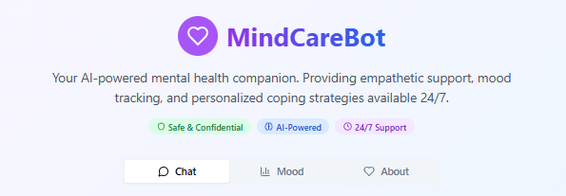

Internal working of tool:

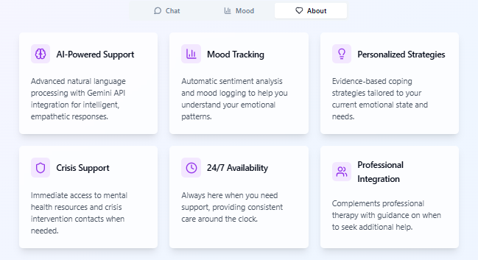

Dashboard of MindCare Bot

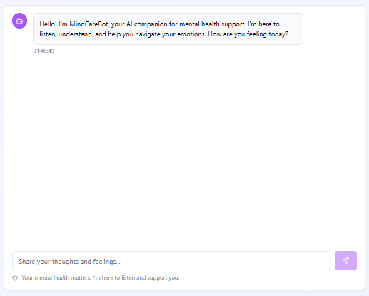

System Functionality – MindCare Bot

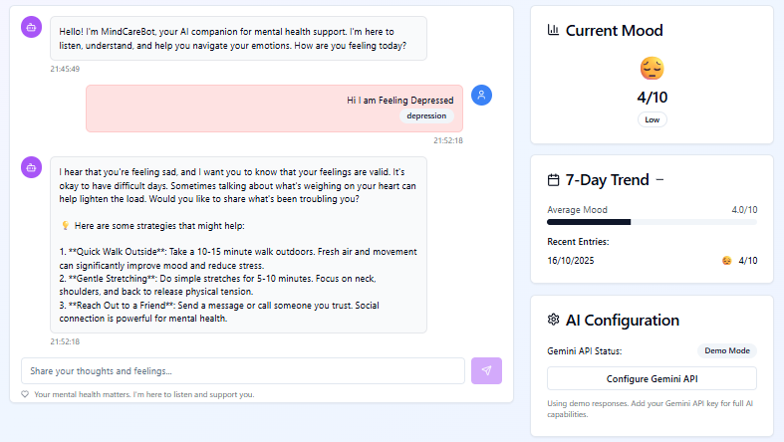

*Step 7: Test – Getting Feedback*

Who did I share my solution with?

I shared my **MindCare Bot** solution with:

* **Students and Young Adults** – to understand how well the chatbot supports emotional well-being and stress management.
* **Mental Health Counselors and Psychologists** – to ensure the chatbot’s tone, empathy, and guidance align with mental health ethics.
* **Working Professionals** – to evaluate usability and effectiveness in managing workplace stress and anxiety.
* **Peers and Mentors** – to gather suggestions on improving features, design, and overall user experience.

What feedback did I receive?

**Feedback: Pros and Cons**

**Pros (Positive Insights from Feedback):**

* Provides instant emotional support.
* Friendly and empathetic tone.
* Helpful resources for anxiety and stress.

**Cons (Areas to Improve Noted in Feedback):**

* Limited offline functionality.
* Needs more personalization.
* Should include voice support for accessibility.

**My Response for The Feedback:**

The feedback helped me identify key areas for improvement, especially in personalization and accessibility. I plan to integrate voice-based chat and multilingual support so users can express emotions more naturally. I’ll also collaborate with certified mental health professionals to validate the chatbot’s responses and ensure ethical, supportive guidance. Future versions will include advanced emotional analytics and adaptive learning to make the chatbot more empathetic and effective over time.

What works well:

**What Works Well:**

1. **Provides 24/7 emotional support, making help available anytime and anywhere.**
2. **Uses empathetic and human-like responses, helping users feel heard and understood.**
3. **Features a simple, calming, and user-friendly interface that encourages consistent use.**
4. **Offers complete anonymity and privacy, reducing stigma and fear of judgment.**
5. **Includes mood tracking and guided relaxation tools to promote emotional awareness.**
6. **Gives quick access to mental wellness resources and emergency helplines when needed.**
7. **Encourages self-reflection and stress management through daily interaction.**
8. **Designed to be accessible and inclusive, supporting users from different age groups.**

What needs improvement:

**What Needs Improvement:**

1. **Currently supports only text-based chats — adding voice conversation would improve accessibility.**
2. **Needs multilingual support to reach a broader and more diverse user base.**
3. **Should include personalized responses based on user history and mood tracking.**
4. **Requires integration with certified mental health professionals for reliable guidance.**
5. **Could add offline functionality for users with limited or no internet access.**
6. **Needs stronger data security measures to ensure user trust and confidentiality.**
7. **Should enhance visual and interactive elements for better user engagement.**
8. **Expanding AI emotion detection capabilities could make responses more empathetic and accurate.**

*AI Tools you can use for Step 6-7:*

**ChatGPT/Perplexity AI/Claude AI/Canva AI/Chatling AI/Figma AI/Metamgx/Gamma AI**: You can use these tools to build solutions/models or mock-up dummy prototypes

**Day 4: Showcase**

**Step 8: Presenting my Innovation**

I am presenting **AI Chatbot for Mental Health**, a digital companion that helps users manage emotions, reduce stress, and seek help safely.

**Features:**

* Empathetic AI conversations
* Mood tracking
* Mindfulness & stress relief exercises
* Emergency helpline integration
* Anonymous and 24/7 access

**Impact:**  
This chatbot promotes mental wellness, reduces stigma, and makes emotional support universally accessible.

**<SHOWCASE YOUR INNOVATION TO YOUR PEERS>**

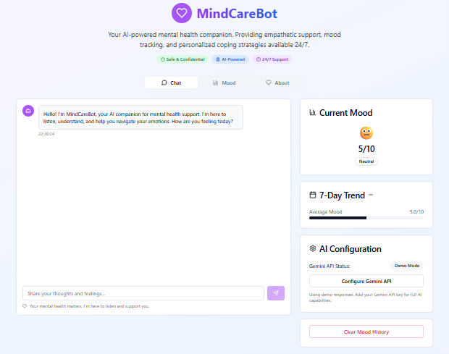

**Step 9: Reflections**

**What did I enjoy the most during this project-based learning activity?**  
I enjoyed creating a chatbot that listens and supports users emotionally. It was inspiring to combine AI technology with empathy to make a real social impact.

**What was my biggest challenge during this project-based learning activity?**  
Ensuring the chatbot’s tone was empathetic and context-aware was challenging. Balancing technology and emotion required careful design and testing.

**Take-home task**

*AI Tools you can use for Step 8:*

**Canva AI:** You can use this to design your pitch document. Download your pitch document as a PDF file and upload on GitHub